# Acceptance Criteria Testing

## Story ID 20

User Story: As the coordinator I want to be able to take pickup requests over the phones so the customers have the ability to create a pickup request if they are unable to use a computer.

* I can manually organise a pickup.
* I can assign a driver to the pickup.
* I can send a confirmation email regarding the pickup.
* I can see the pickup request in the pending pickup list.

NOTE: Shortly into development of this sprint, drastic changes were made to the plan. We realised that this functionality would essentially be akin to the booking page in the regular dashboard, only all the details would be entered manually by the coordinator.

As such the following acceptance criteria derived from story 8 (Book new packages) seems more appropriate.

* I can enter the customer’s details (shipper) & enter the recipient details & enter the package details (weight, size etc).

I can enter the customer’s details (shipper)

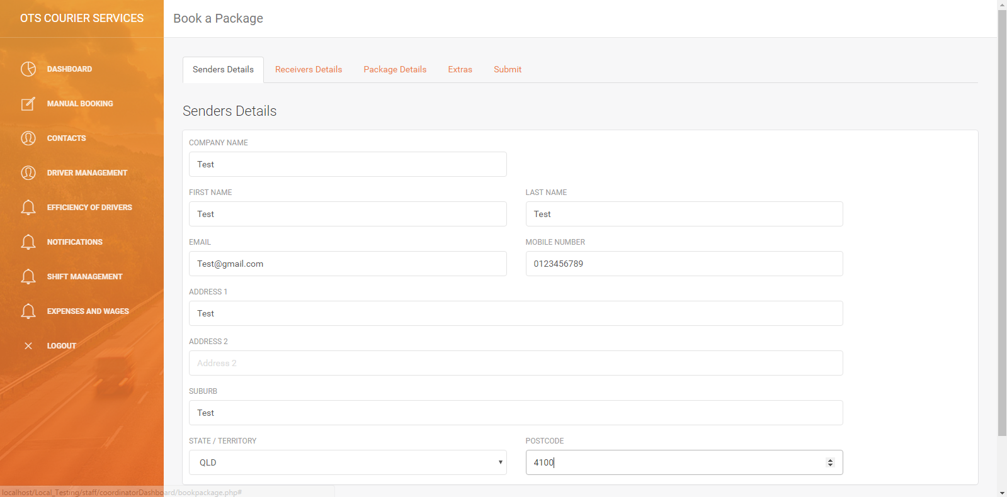

I can enter recipient details

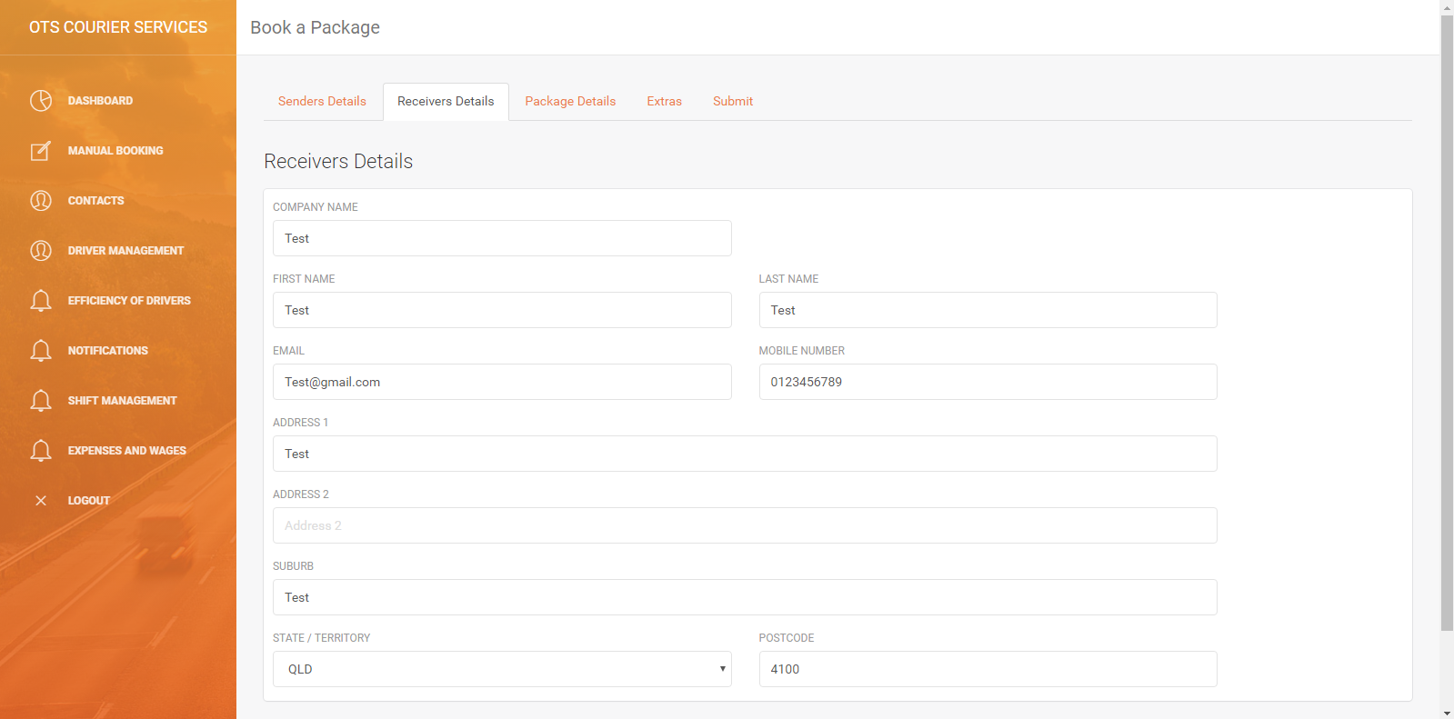

I can enter the package details

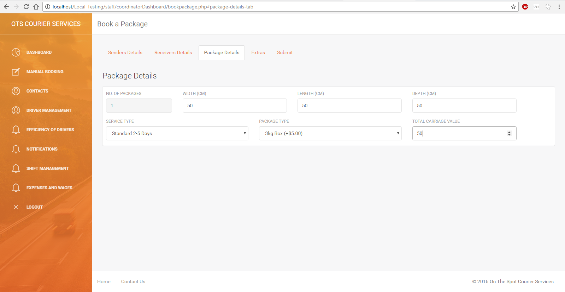

I can select the type of payment on pickup and get cost of shipping

Before booking I get the cost to ship the package so that the customer can have the money / payment type ready for when the driver picks up the package

I get a confirmation that the package has been booked